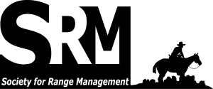
SRM Trade Show & Sponsorship – Allen Press
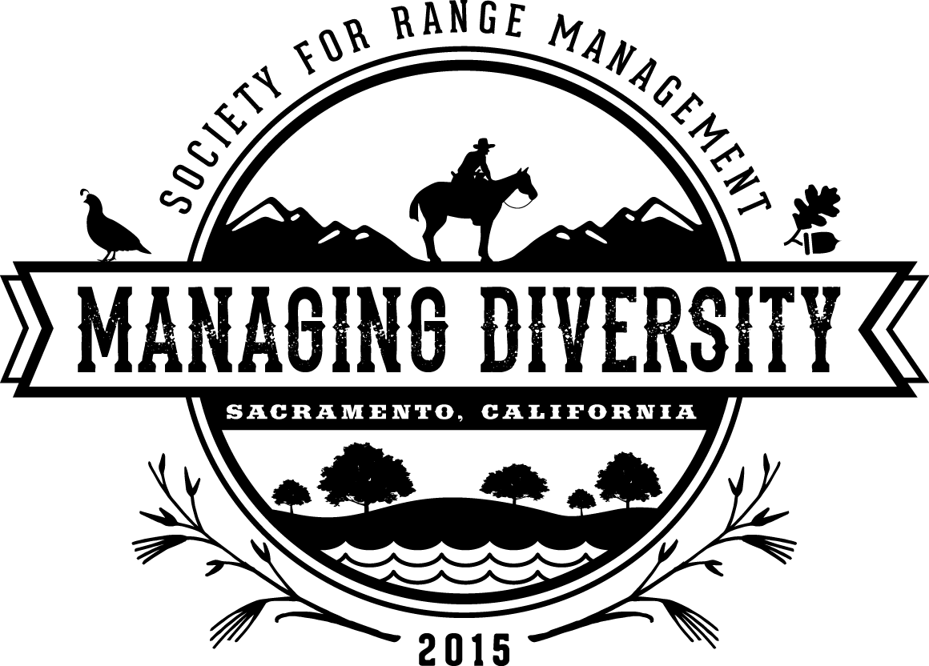
Society for Range Management
6901 S. Pierce St. Ste. 225
Littleton, CO 80128
http://rangelands.org (303) 986-3309 info@rangelands.org
810 East 10th St.
Lawrence, KS 66044

July 21, 2014

Dear Exhibitor/Sponsor,

The Society for Range Management (SRM) is pleased to invite you to be an exhibitor and sponsor at the upcoming 2015 Annual Meeting in Sacramento, California, January 30 - February 6th. The Trade Show will be held in the Sacramento Convention Center in downtown Sacramento. Meeting attendance is anticipated to reach more than 1,500 individuals from a diverse audience, including representatives from the ranching, research, land management agency, and practitioner communities. SRM Trade Shows have proven to be successful, well-attended events, for more than 15 years.
The Society for Range Management and the local Annual Meeting Planning Committee have been working diligently to ensure that the Trade Show is a success for the 2015 meeting. Efforts to promote attention and traffic flow in and around the Trade Show floor include: live range/livestock related demonstrations, meeting registration located adjacent to the Trade Show floor, a poster sessions that will be incorporated on the Trade Show floor, an annual Silent Auction, a Super Bowl party and Trade Show mixer on opening night, and a food court and Annual Meeting-hosted free coffee breaks in the Trade Show area. Additionally, costs for power and Internet access at booths are reasonably projected to be $25 for a power drop and $35 for an Internet access booth code for the entirety of the meeting.
The Sacramento Trade Show will last from Sunday afternoon to Tuesday afternoon. This will allow you and your organization the opportunity to exhibit our Producer Forums when additional crowds are expected. Trade Show set up will be Sunday afternoon, February 1, 2015 with a mixer and Super Bowl party, the following day it will open at 8 am prior to the Monday morning plenary session, scheduled to be directly adjacent. The Trade Show will end at 3:00pm Tuesday, February 3, 2015 therefore meeting your busy schedule.
Trade Show booth selection is based on a first come, first served basis. Your early registration will ensure the best selection of booth space at the Sacramento 2015 meeting. Commercial vendors who are also event sponsors will get to select their preferred booth location. To register, please visit us online at: www.rangelands.org/events or return the enclosed application. Booths are competitively priced, and will gain valuable exposure for your organization. Thank you for considering joining us for the 2015 Annual Meeting in Sacramento. Please get in touch with Tacy Curry (direct: 707-678-5958) or Ceci Dale-Cesmat (direct: 530-251-7857) with any questions and we look forward to seeing you there.

Sincerely,

Ceci Dale-Cesmat
Trade Show Committee Chair

